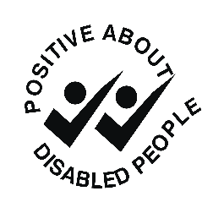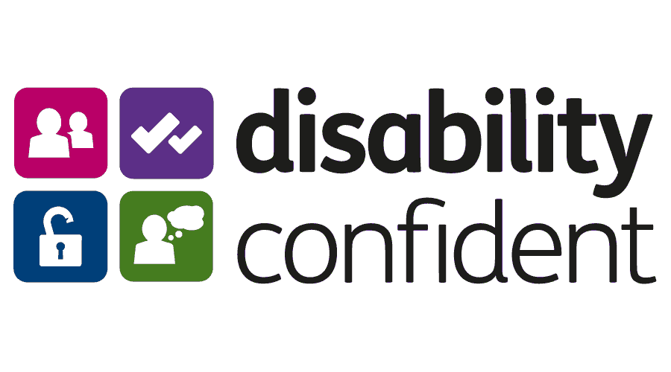

Assistance Request Form

If you require this form in an alternative format, please let us know
Communities 1st is committed to the employment and career development of disabled people.
The Equality Act 2010 defines someone as a disabled person if a) they have a physical or mental impairment; and b) the impairment has a substantial and long term adverse effect on their ability to carry out one or more normal day-to-day activities.
We will happily provide assistance should you require it if invited to an interview or assessment.
Do you require assistance if invited to an interview / assessment?
Yes ☐ No ☐

If yes, please provide us with more detail on the specific requirements or equipment you may need:

Name:
Date:

If applying for assistance, please complete this form and attach with your application. We wish you the best of luck with your application!

Guaranteed Interview Scheme Request

If you require this form in an alternative format, please let us know
Communities 1st is committed to the employment and career development of disabled people.
We guarantee to interview anyone with a disability whose application meets the minimum criteria for the post. By ‘minimum criteria’ we mean that you must provide us with evidence in your application which demonstrates that you generally meet the level of skills and experience defined as essential within the person specification for the position.
The Equality Act 2010 defines someone as a disabled person if a) they have a physical or mental impairment; and b) the impairment has a substantial and long term adverse effect on their ability to carry out one or more normal day-to-day activities.
Do you wish to claim an interview under the Guaranteed Interview Scheme?
Yes ☐ No ☐

Name:
Date:

If applying under this scheme, please complete this form and attach with your application. We wish you the best of luck with your application!

