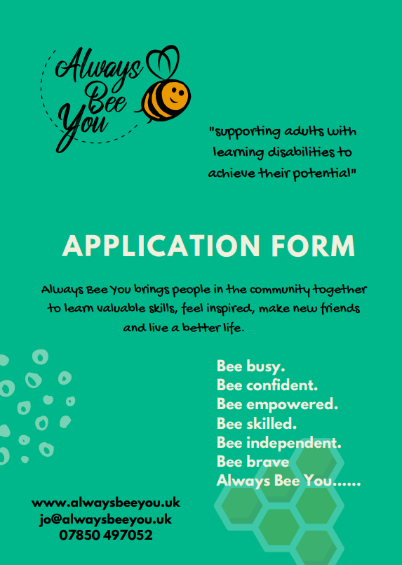
MY PERSONAL
INFORMATION

Name:…………………………………………………………

Date of Birth:………………………………………………

Address:……………………………………………………..
……………………………………………………………………
……………………….…………………………………………..

Home Telephone Number:………………………….

Mobile Number:………………………………………….

My Next of Kin:……………………………………………

Relationship:………………………………………………

Telephone Number:……………………………………

Social Worker:……………………………………………

Contact Number:………………………………………...

Student Signature:……………………………………...

Services available with
Always Bee You:

Always Bee Social (Wednesday Evenings 6pm to 9pm)
Always Bee Delicious (Prepare & Serve a Vintage Afternoon Tea)
Always Bee Growing (Plant & Grow Activities)
Always Bee Crafting (Experiment with your creative side)
Always Bee Healthy (Swimming)

Please indicate the services you
are interested in:
1……………………………………………………

2……………………………………………………

3……………………………………………………

4……………………………………………………

5……………………………………………………

PERSONAL HEALTH
INFORMATION

Please let us know if you have any
particular health conditions.
(i.e. diabetes)
…………………………………………………………………...
…………………………………………………………………...

Do you have any difficulties with
mobility?
(e.g. poor sight)
…………………………………………………………………...
…………………………………………………………………...

Do you use any aids for mobility?
(e.g. wheelchair)
…………………………………………………………………...
…………………………………………………………………...

Do you suffer with certain illness?
(e.g. chest infections)
…………………………………………………………………...
…………………………………………………………………...

Are you allergic to any food or drink?
……………………………………………………………………
……………………………………………………………………

